Press Release
Expert reports and evaluation in times of crisis:
An innovative approach by VALUPLEX
With VALUPLEX, industrial auction house Surplex has founded a new and independent business unit that offers professional assessments and evaluations. We asked the Managing Director of VALUPEX Christoph Partzsch what sets VALUPLEX apart from its competitors and why this difference particularly matters in times of crisis.
Even before the coronavirus crisis started, German industry was under high pressure to change, most notably in automotive sector. What started as a structural crisis with the diesel emissions scandal, e-mobility and autonomous driving has now been accelerated by the pandemic. Meanwhile, not just Germany but the entire global economy is in crisis mode. Insolvencies, plant closures and restructurings are likely to increase. A wave of takeovers is to be expected. Where sites are being closed and production processes restructured, machinery adjustments are unavoidable. Surplus assets have to be assessed, evaluated and sold as profitably as possible. The demand for professional industry assessments and evaluations should therefore grow.
Last year’s foundation of VALUPLEX is a fitting response to this development. Established as an independent line of business, VALUPLEX is set to help companies gain an overview of the value of their fixed assets - quickly and in line with the market. The Managing Director of VALUPLEX, Christoph Partzsch, an expert in used metalworking machinery with many years of experience, explains the added value from a customer’s point of view: “Our experts evaluate machinery and inventory quickly and reliably. Their expertise is an excellent foundation upon which to generate immediate liquidity or commission revenue optimised marketing.” Partzsch emphasises that while VALUPLEX has full access to the resources of Surplex GmbH - the industry auction house with branch offices in twelve European countries which carries out more than 500 industry auctions per year – it also has full autonomy from Surplex.
Besides industry clients, insolvency administrators, restructuring consultants, banks, and leasing companies, VALUPLEX also supports smaller trade firms. Demand in this sector has been rapidly growing, too, says Partzsch: “This has nothing to do with the pandemic or the structural crisis, however, but is instead a result of demographic change.” Many master craftsmen are currently looking for a successor without any success. Should a business now be liquidated or sold, an assessment of fixed assets in line with the market is indispensable. This can also help uncover hidden reserves and present them to possible buyers.
But what sets VALUPLEX apart from the competition? “If you analyse the market, you will discover lots of things that can be improved,” Partzsch explains. “We do not only offer our industry and trade clients a targeted consultation but also more precise assessments that we compile more swiftly. VALUPLEX speeds up all processes: “After you put in a request with us, we get back to you with a fair, non-binding offer within 48 hours.” Once the order is placed, VALUPLEX gets cracking: “Our assessment department gets to work while the expert is still doing the inventory. We call this a hybrid approach.” But it is above all the quality of the assessments that separates the wheat from the chaff, says Partzsch: “We stand out from the crowd of competitors because we are one of the few service providers that offer assessments for certain core sectors.” Meanwhile, the market is dominated by generalists. This is justified, of course, but in this way the value of fixed assets can often only be roughly estimated: “That is why specialists are needed, although they have been hard to find,” Partzsch stresses. This gap in the market is now closed because VALUPLEX can build on the collected know-how of many machinery experts who have specialised knowledge in a clearly defined market sector: “When we evaluate a carpentry or a locksmith’s shop, for example, our experts have often previously worked as master carpenters or master locksmiths themselves. They often know the machinery from personal experience. This means consultations on a level playing field.” As a result, assessments by VALUPLEX are significantly more precise than is usual. This especially applies to metal and woodworking where VALUPLEX has an unrivalled level of market knowledge. The higher quality of the assessments is not only based on personal experience, however, but is also a result of a strong data-driven approach to evaluation, says Partzsch: “Our experts draw from real selling prices.” For this, they have access to the largest database in the sector with regard to VALUPLEX’s core areas. Current hammer prices from countless online auctions all over Europe are continually added to this: “Our experts therefore calculate liquidation and continuation values that are significantly higher than those estimated by generalised evaluations,” says Partzsch.
So VALUPLEX experts not only work faster and more precisely than competitors. If needed, they can usually offer a better buying price to clients through Surplex GmbH as well. This means more cash for clients. And in the case of a marketing request, for instance at an online auction, the expected proceeds can be better calculated based on realistic market prices. VALUPLEX is so convinced of the quality of their own assessments that it even offers guaranteed proceeds under certain circumstances. “An absolute rarity in the market,” stresses Partzsch. it makes sense, particularly in times of crisis, to seek out new approaches to business assessments. This is true for small and medium-sized businesses as well as for international companies. If needed, VALUPLEX is here to help as a service provider that delivers fast results that are specialised, in line with the market and even offers the option of guaranteed proceeds. Transformation processes, whether through insolvency, closure or restructuring, always pose a great challenge. This makes the importance to optimise results, keep costs as low as possible and have a reliable partner by your side even bigger.

Press contact:

Surplex GmbH
Dennis Kottmann
Theodorstraße 105
40472 Düsseldorf Germany
Telephone: +49 211 422737-28
dennis.kottmann@surplex.com
www.surplex.com

Images:

VALUPLEX logo

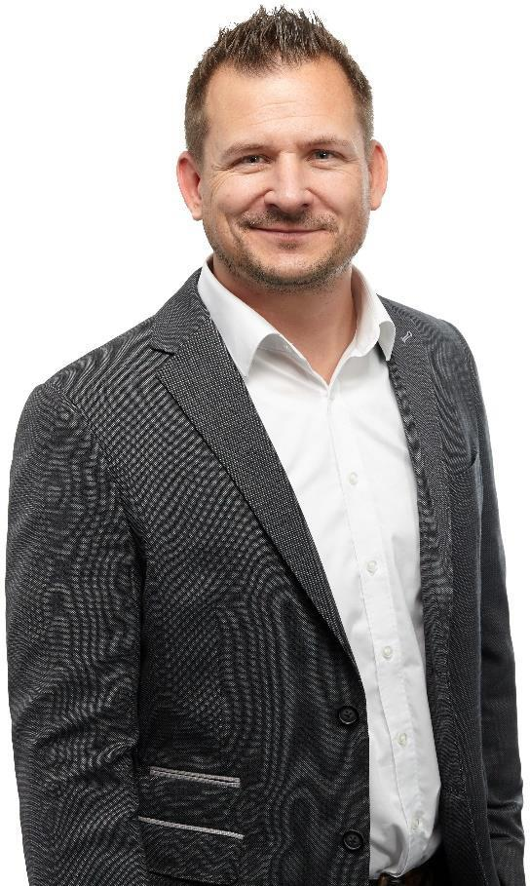
Christoph Partzsch, Managing Director of VALUPLEX

