Site closure of the world's largest manufacturer of construction machinery

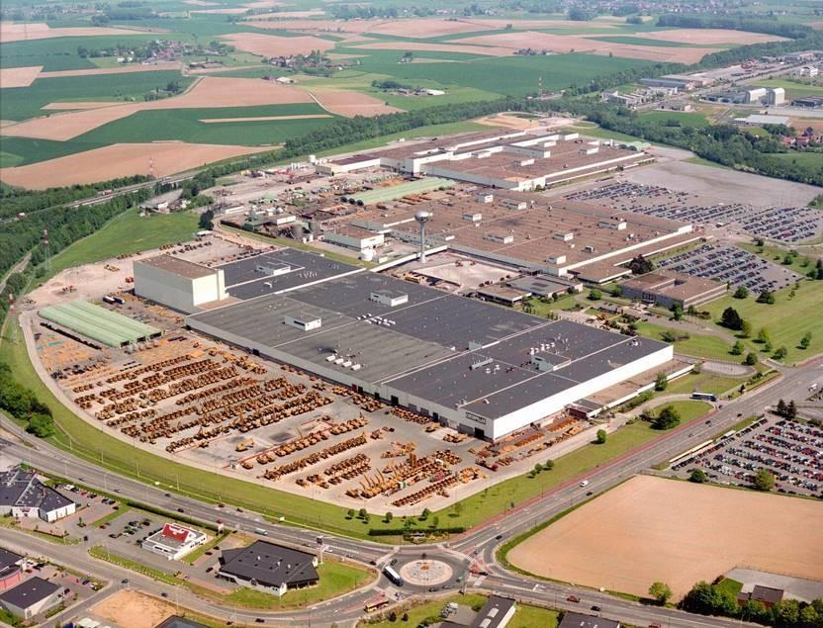
A big challenge: Site closure in Gosselies, Belgium

Industrial Auctioneer Surplex Wins the Tender for Marketing of Total Fixed Assets in Gosselies, Belgium
When the world's largest construction equipment manufacturer closed its plant in Gosselies, Belgium, in autumn 2017, the Walloon regional government undertook a great deal to ensure the continued use of the plant's premises. In the meantime, discussions are taking place with investors from all over the world, including a Chinese manufacturer of electric cars. So it is important now to achieve optimum value for the extensive assets and clear the factory premises quickly to hand them over to the new investor.
Surplex GmbH from Düsseldorf was recently commissioned with this task. The company was able to win this commission against competition from well-known competitors in a lengthy tendering process. Surplex made the best offer from all the industrial recyclers involved and was able to substantiate this with evidence of numerous major projects undertaken across Europe.
Now thousands of items need to be cleaned, photographed, catalogued and described in 16 languages - from hand tools to bridge cranes to heavy vertical turning machines. Since September 2019, high-quality gear cutting lines and other machinery are on offer on the Surplex website in direct sales. From October 2019, a series of online auctions will be launched that will extend into the second half of 2020. Among other things, the range includes high-quality vertical lathes, CNC machining centers, gear cutting and grinding machines from well-known manufacturers. After these sales, Surplex organizes the dismantling and transport of the machines and, in the case of sales to non-EU countries, also takes care of the customs clearance. The clearance of the workshops will be completed in early 2021.
Summary:
Gosselies (Belgium) - industrial user Surplex wins tender and is now responsible for the complete site closure of the world's largest manufacturer of construction equipment. Thousands of items are sold directly on www.surplex.com or auctioned online, including high quality gear cutting lines. The eviction should be completed by the beginning of 2021.

About Surplex:
Surplex is one of Europe's leading industrial auctions and trades worldwide with used machinery and equipment. The 16-language auction platform surplex.com records approximately 50 million page views annually. More than 55,000 industrial goods are sold each year at more than 500 online auctions. The company based in Duesseldorf (Germany) has offices in eleven European countries. More than 200 employees from 24 nations generate an annual turnover of approx. EUR 100 million.

