Press Release
20 Years of Surplex: from a Dot-Com Start-up to No. 1 in the European Machinery Trade
Nothing seems as powerful as an idea whose time has come. But if the idea comes too early, you need to let the time ripen if you want to make the most of it! This is roughly how the 20-year history of Surplex can be summed up. The company starts in October 1999 as Surplex.com AG, becomes the star of the New Economy, disappears with the dot-com bubble for many years in the niche, reappears in 2009 as Surplex GmbH and stands today stronger than ever before.
At the turn of the millennium, the Internet was still in its early stages. But some visionaries were already trying to implement what will only be possible 10 years later. The founding generation of Surplex, and especially Bruno Schick, intended to disruptively change the trade in used capital goods. From this perspective an online marketplace should make all processes faster, simpler and more transparent. But neither the technical nor the psychological prerequisites existed yet. The high-speed Internet has not yet been invented. And hardly any prospective buyer was willing to pay five or six-digit amounts online.
Therefore Surplex.com AG could not escape the dot-com crisis. Sales were stagnating and no further venture capital was forthcoming. The company closed all its local branches and dismissed the majority of its staff. Nonetheless, Surplex remained in the market but lost its independence. From 2004 to 2008, it will be run under the umbrella of a sales company by Michael Werker who will then consolidate it together with Uli Stalter.
The new leading duo remains firmly convinced that online auctions are the sales format of the future. They are among the first to invest in a powerful auction platform. Yet at the same time, they realise that it is not enough to offer purely digital services. This is why they also rely on analogue services, which over the years have been developed into a holistic ISO-certified solution. Surplex now personally supports and advises its customers, prepares expert appraisals and assesses machines. Once the goods have been purchased, the company takes care of disassembly, transport, customs and payment procedures. In this way, Surplex combines the best of two different worlds into an attractive overall package. Michael Werker and Uli Stalter founded Surplex GmbH with this strategy at the beginning of 2009, i.e. during the financial crisis and took the first step towards a new independence.
The response of the market exceeds all expectations right from the start. Already from 2009 to 2010 the GmbH records two-digit growth rates. Of course, there are some industrial auction houses on the market that organise online auctions. However, they lack competent service, especially in the after-sales area. And vice versa, many classic machine dealers are strong in service, but they do not offer the strong growing online auctions. Surplex ventures right into this gap, which leads to explosive expansion. From 2009 to 2019, the number of employees rises from 15 to over 200, and sales climb to over 100 million euros.
In the year 2013, the step towards internationalisation follows. Surplex S.r.l. (Italia) is the first branch office outside Germany to be founded. By 2019, nine more will be established, bringing Surplex to eleven European countries, including Spain, France and the UK. In addition, Surplex now provides customer support in over 20 languages. When it comes to auctioning used metalworking and woodworking machinery, Surplex is No. 1 in Europe.
The core of the success story remains the auction platform surplex.com, which is available in 20 languages and records more than 55 million-page views each year. Over 500 online auctions were held in 2018, with more than 55,000 capital goods sold. An excellent starting position for the next 20 years! Unlike in the dot-com era, Surplex is now expanding sustainably. The company is pushing ahead with the digitalisation of the machinery trade. It implements the founders' visions, though this time on solid foundations because the time has come
Press contact:
Surplex GmbH
Dennis Kottmann
Theodorstraße 105
40472 Düsseldorf
Germany
Tel.: +49 211 422737-28
dennis.kottmann@surplex.com
www.surplex.com

Press Release 20 Years of Surplex: Photos
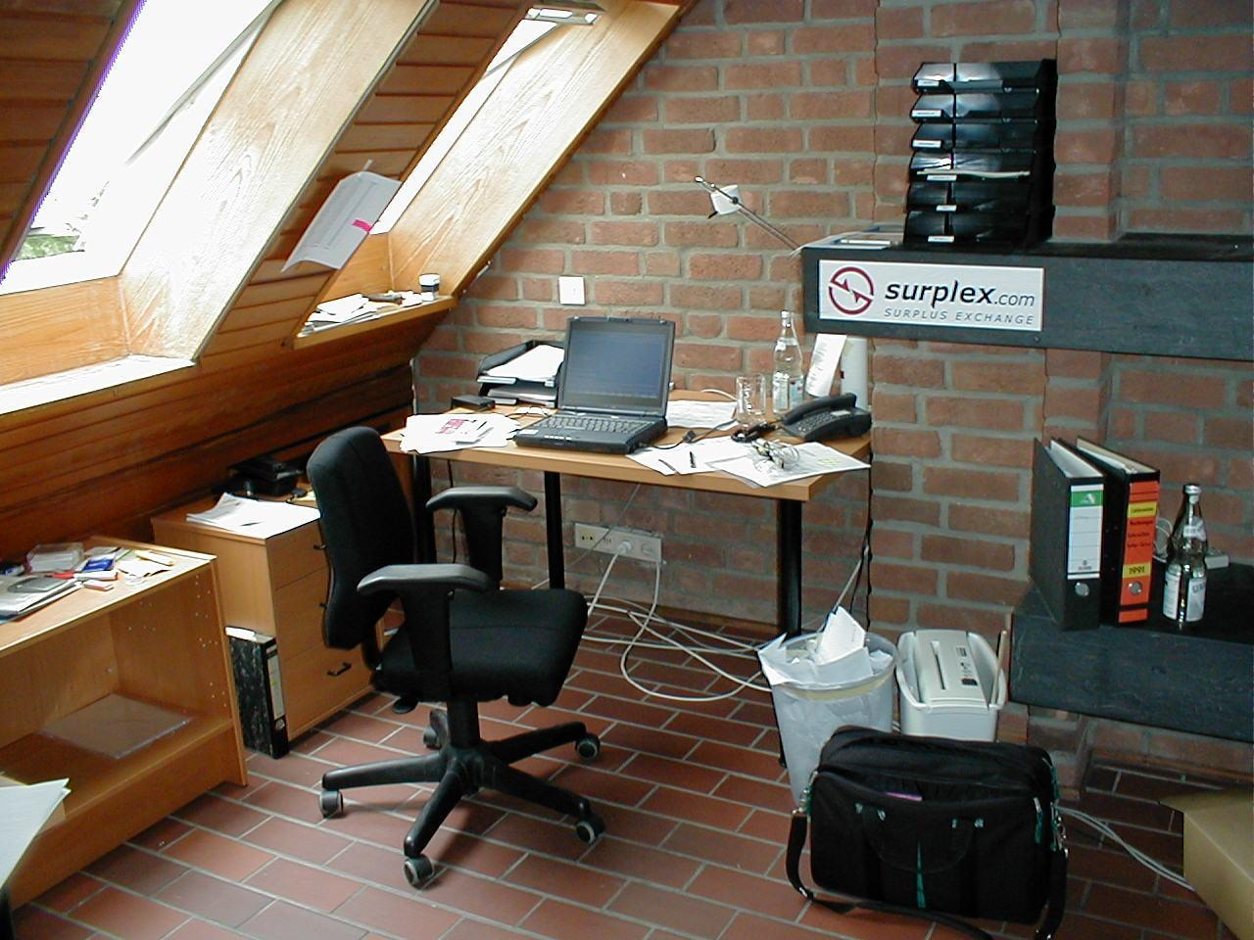
1999: First Surplex office
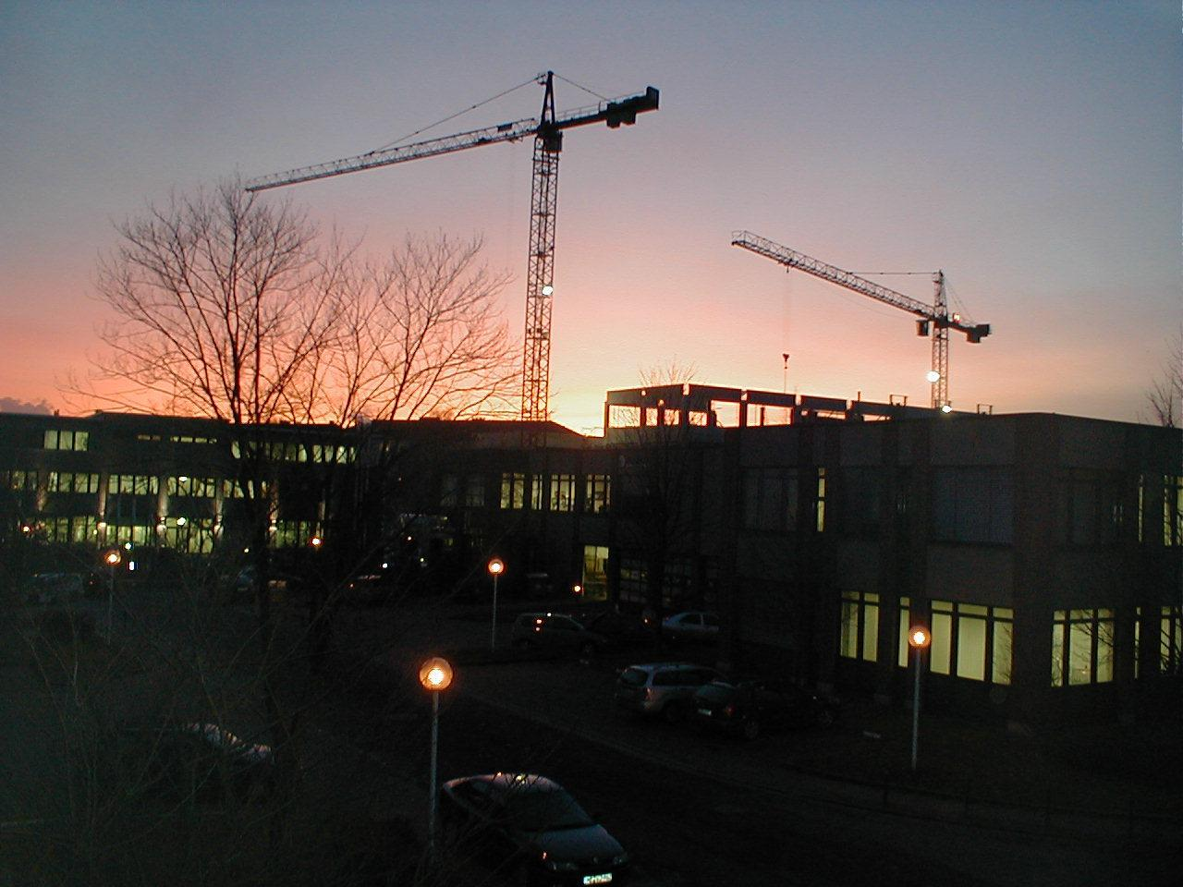
2001: Crisis twilight over Berlin - the dot-com bubble bursts
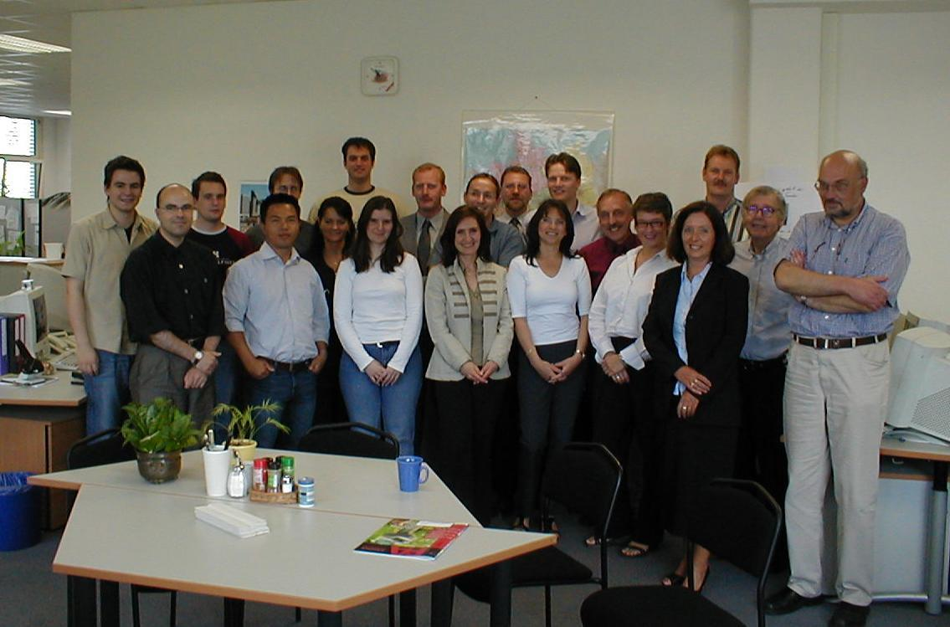
2004: The entire Surplex team

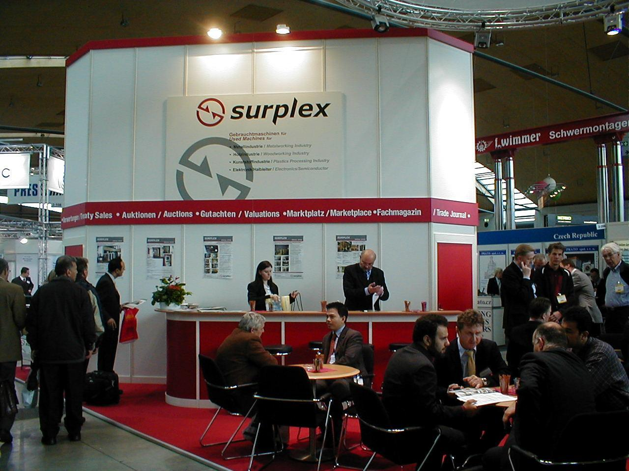
2007: Trade fair stand at RESALE
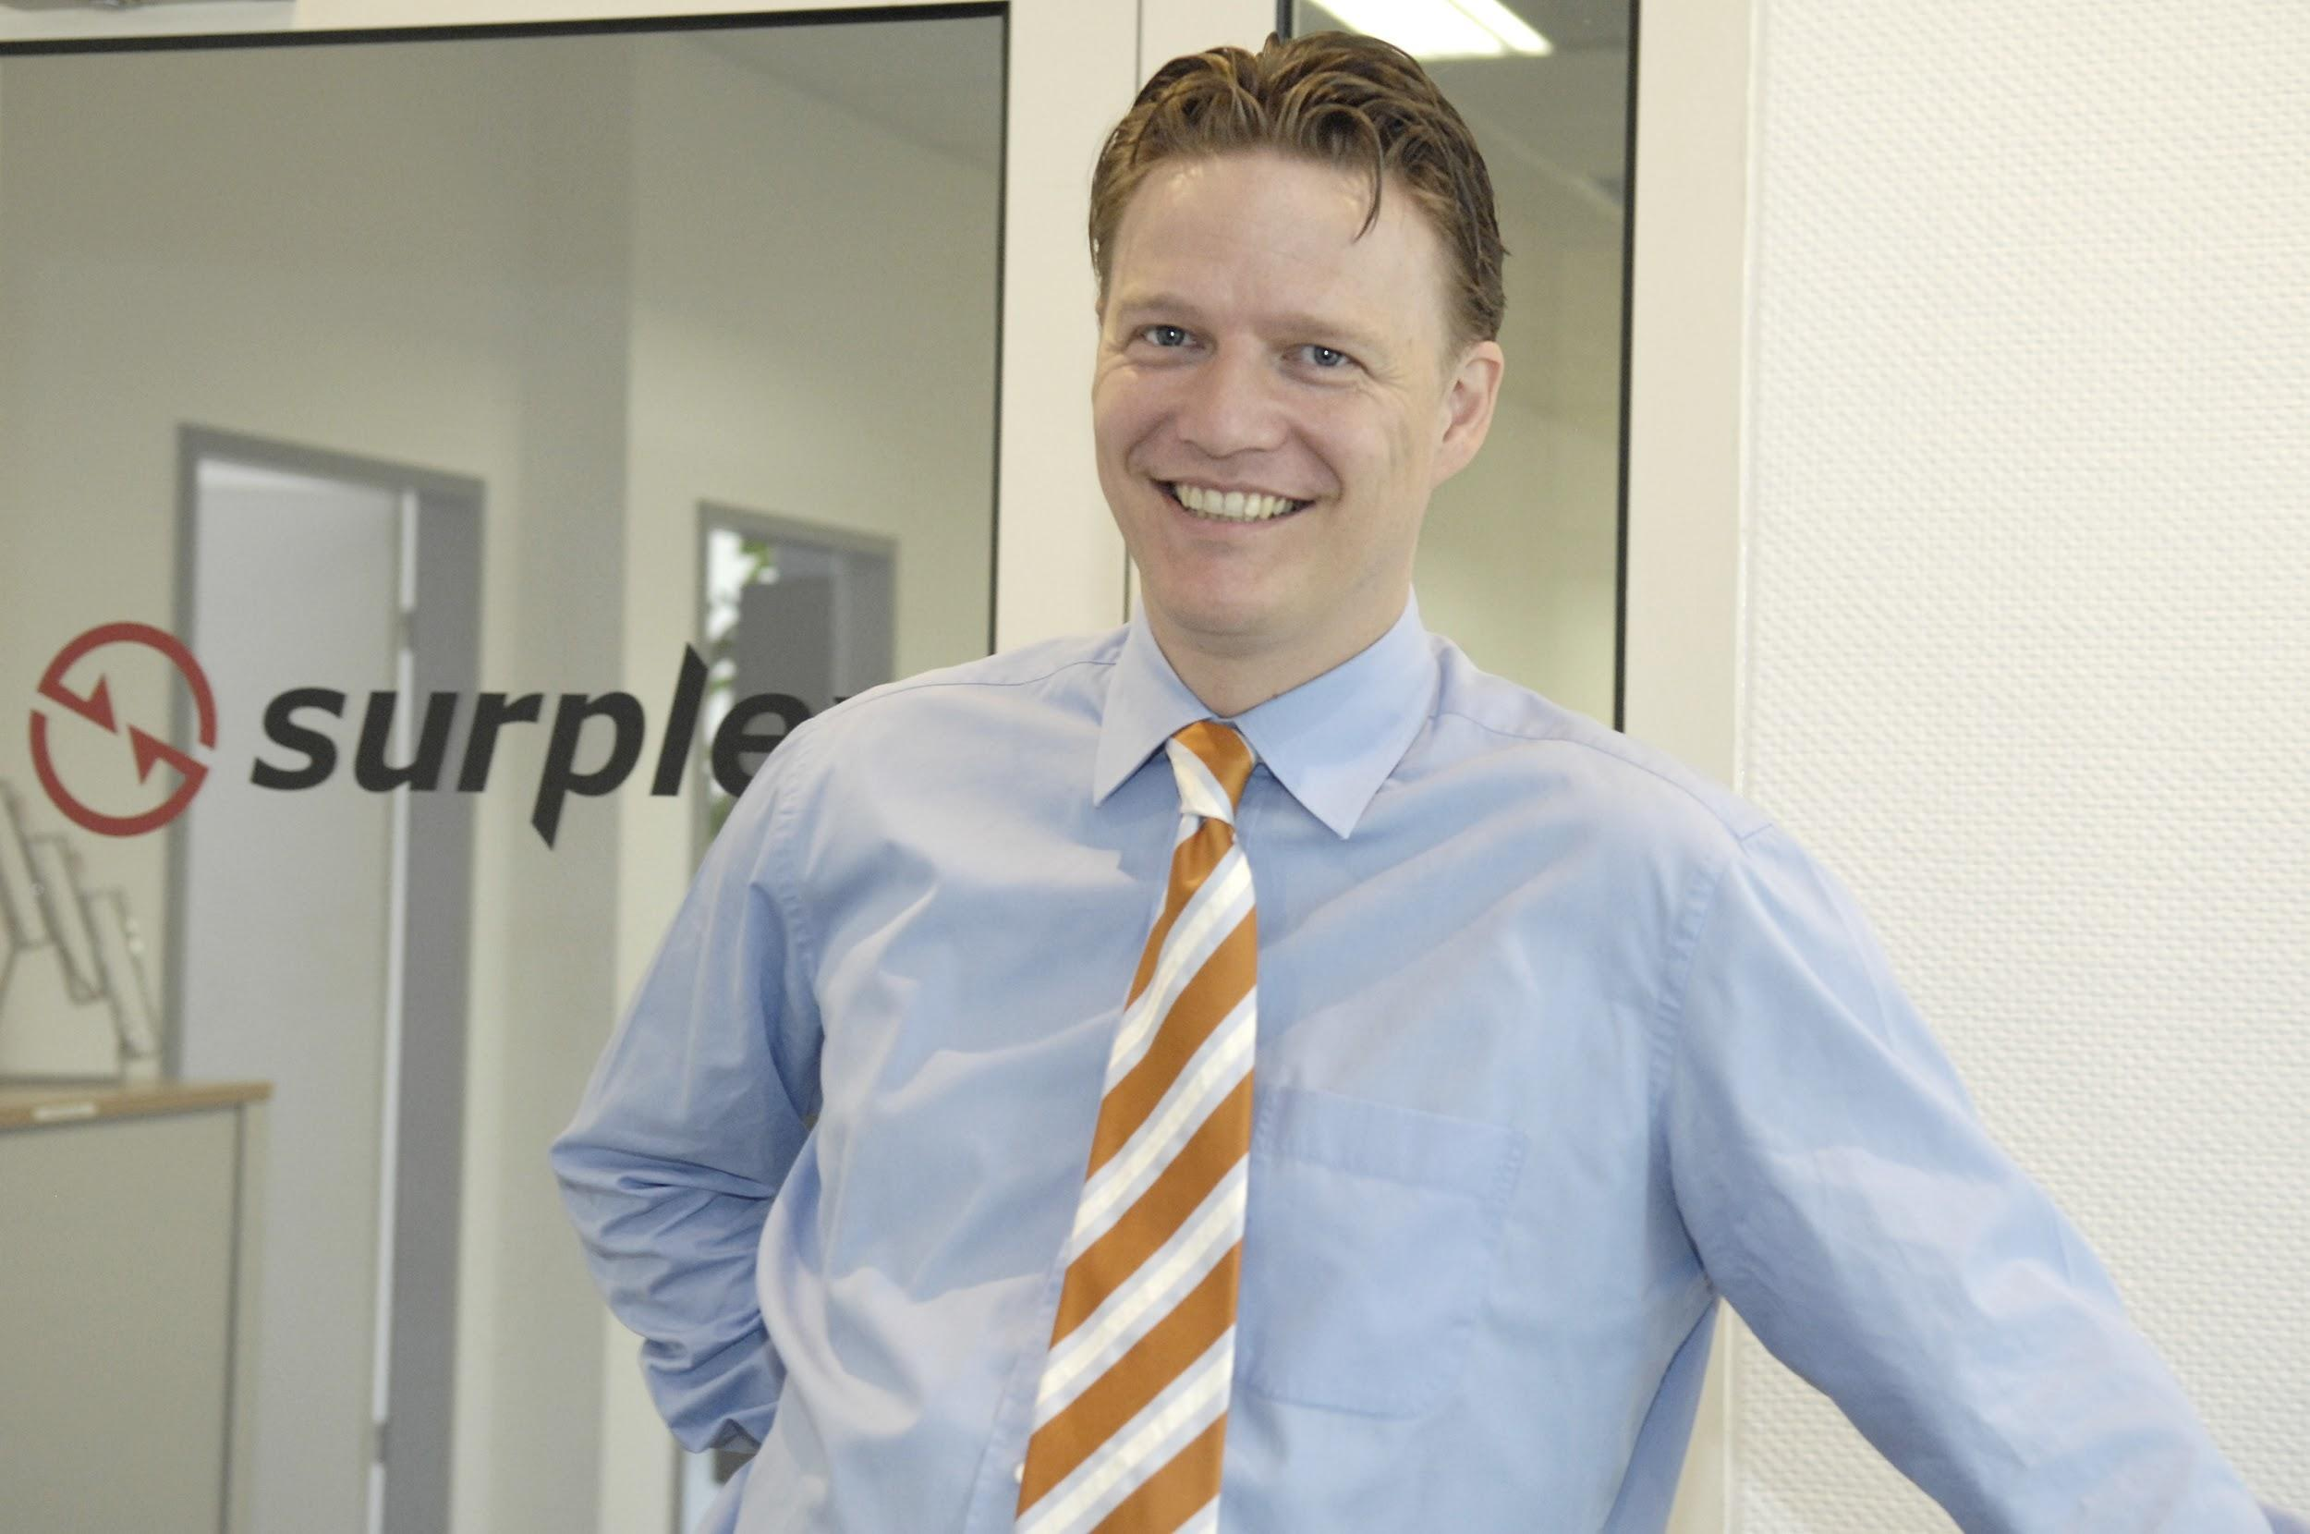
2008: Michael Werker (MD)
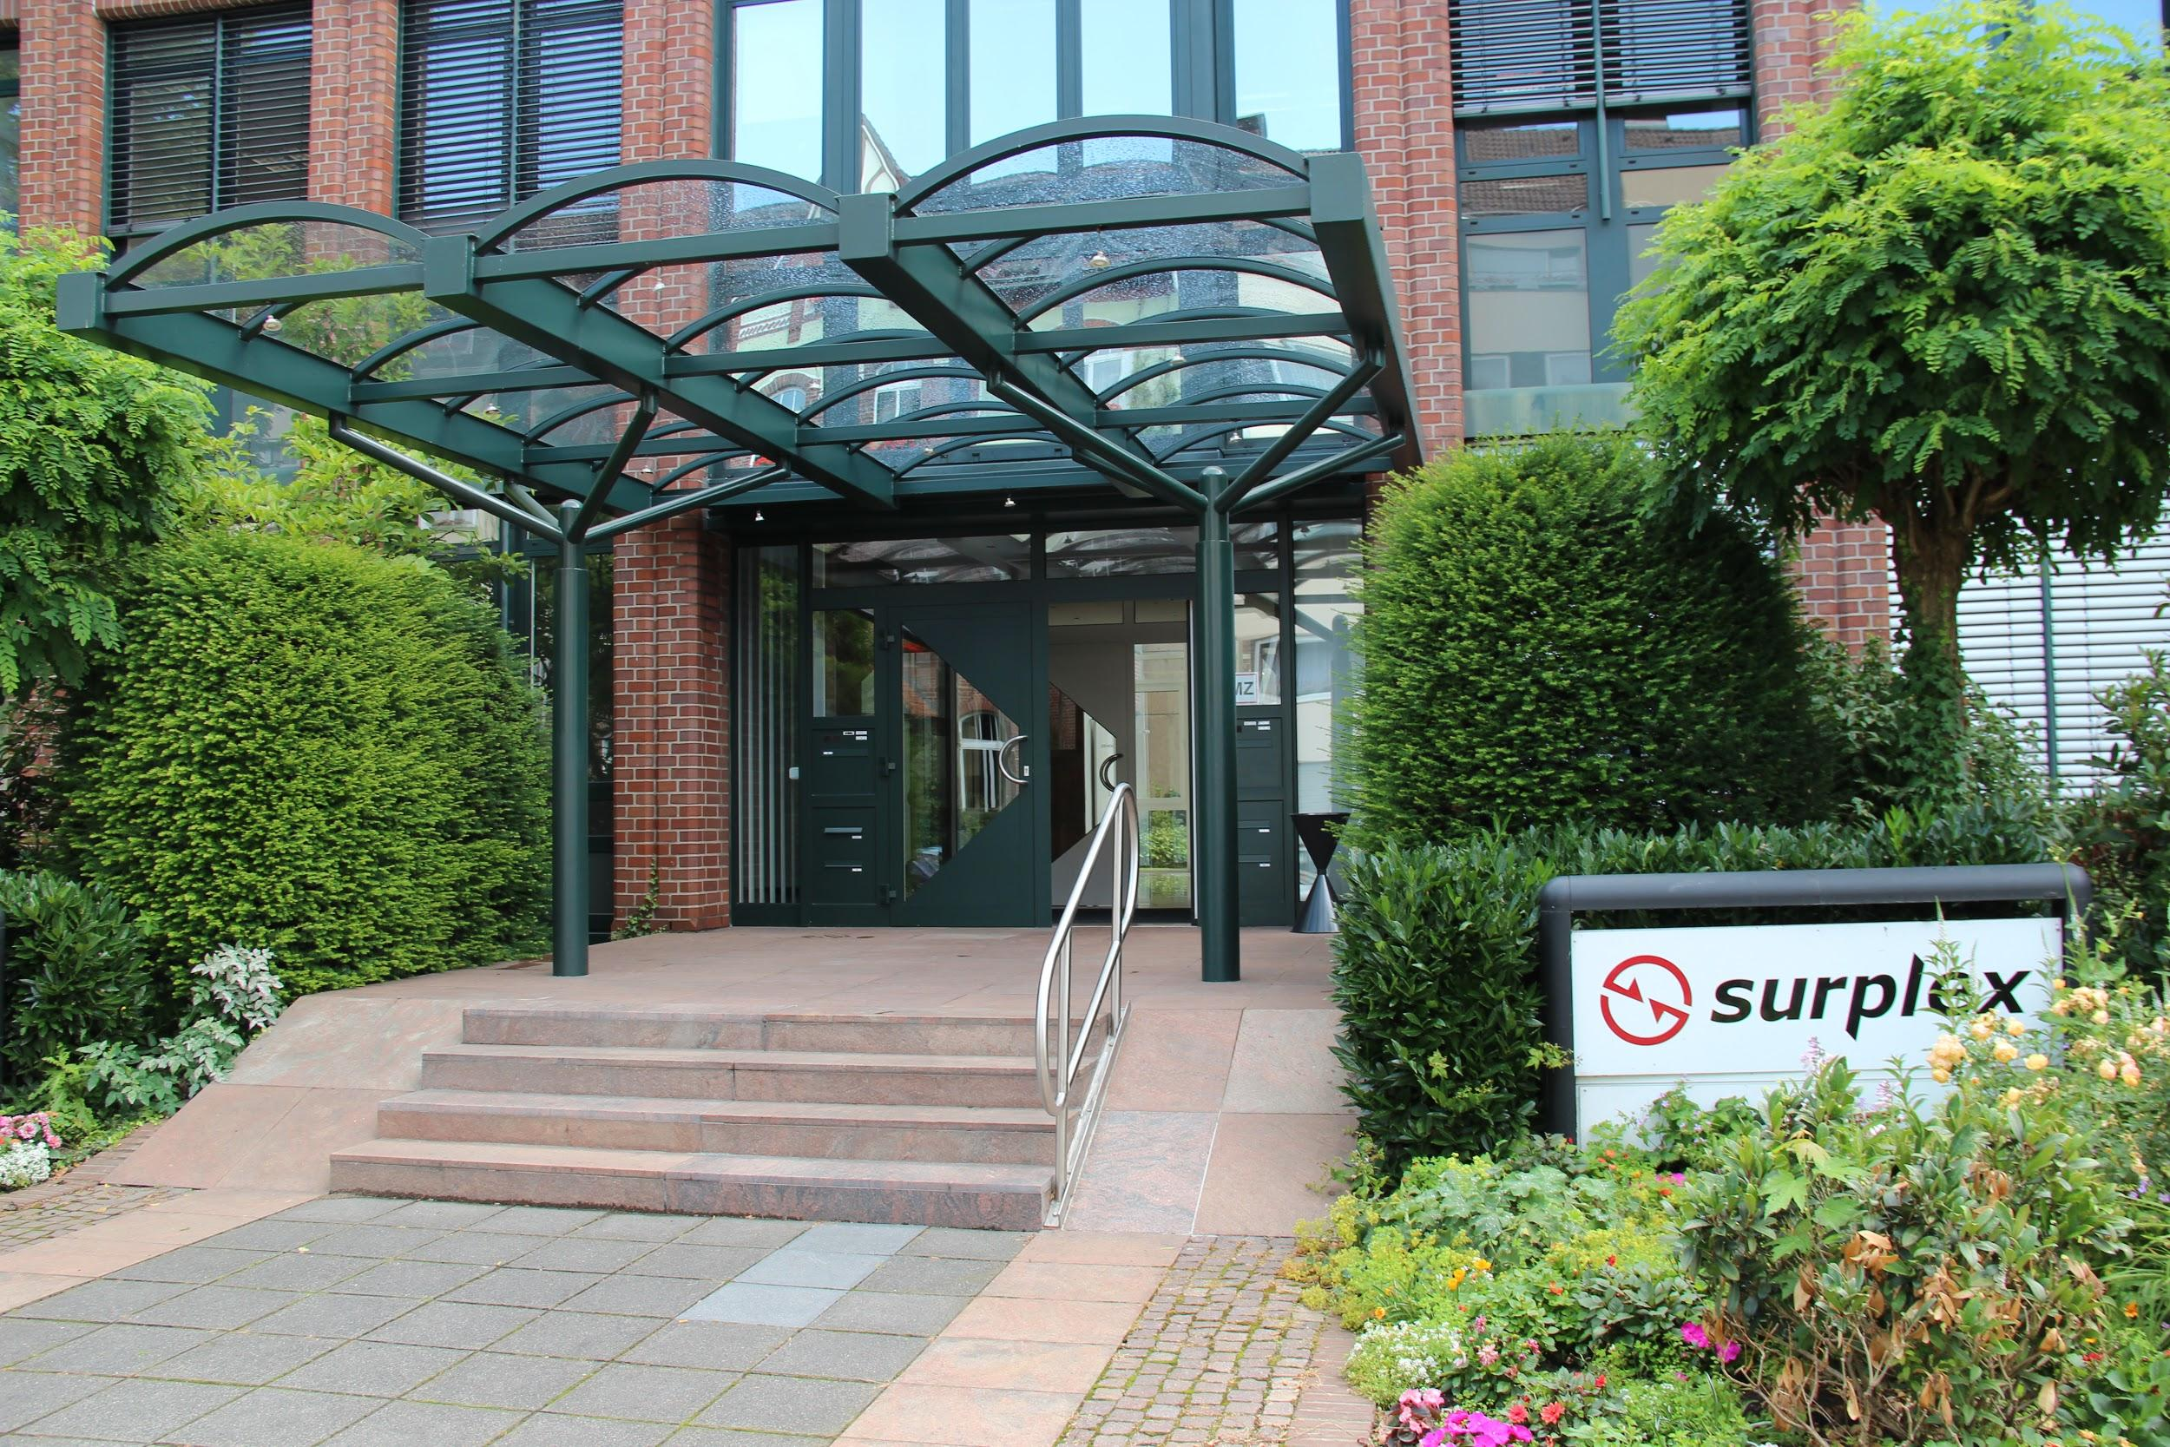
2009: The first office of the new Surplex GmbH
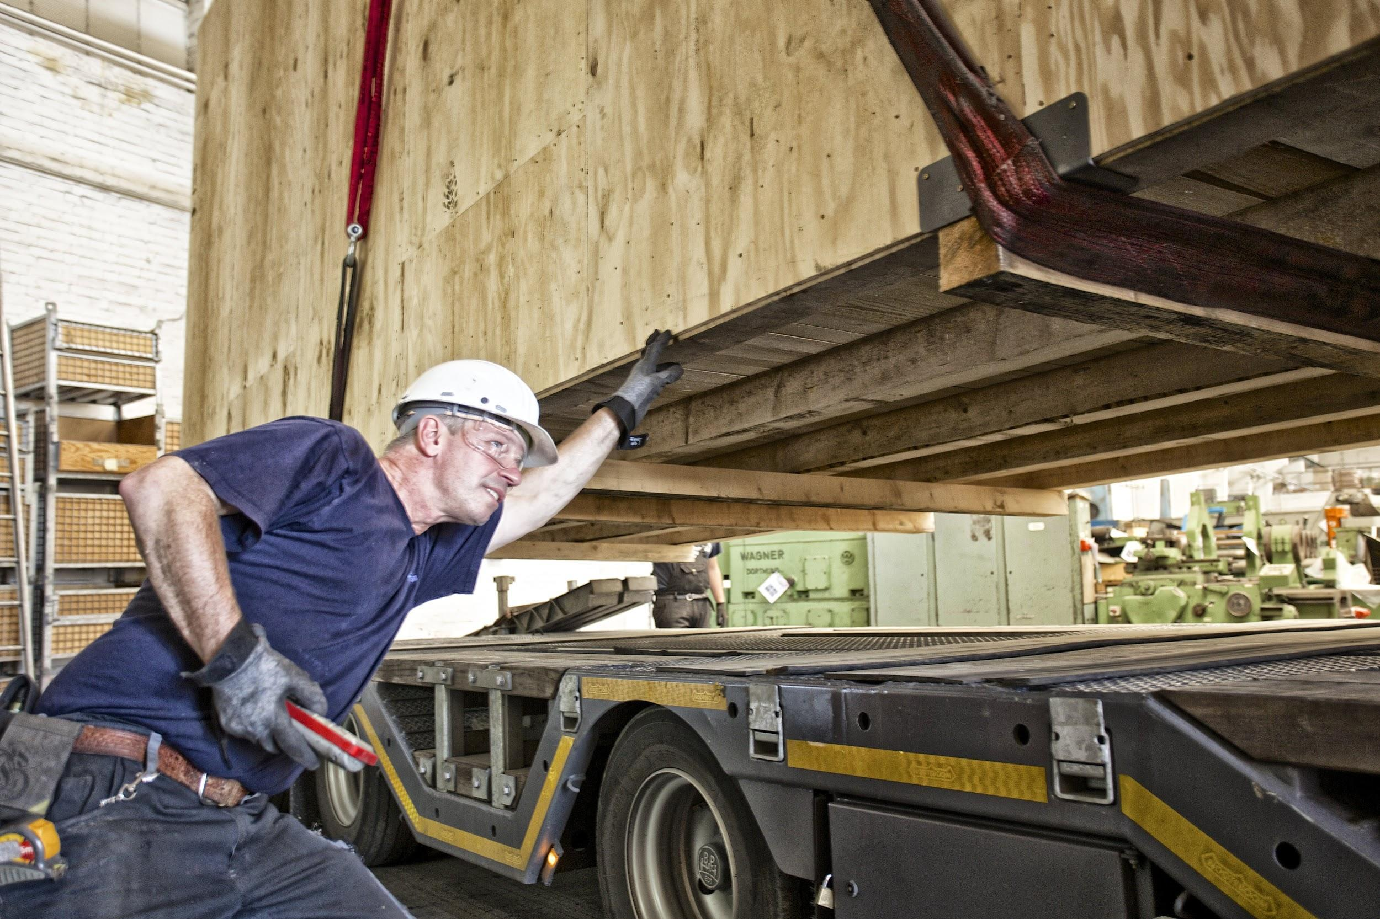
2011: Machinery loading
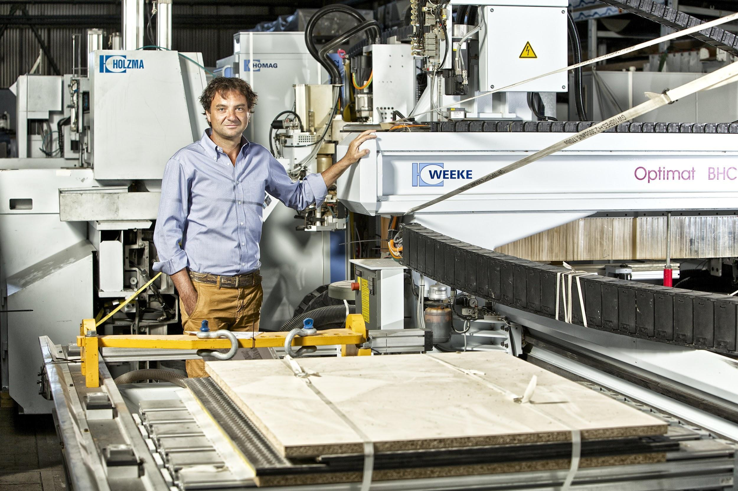
2013: Country Manager Guido Franchini, Surplex Italia S.r.l.
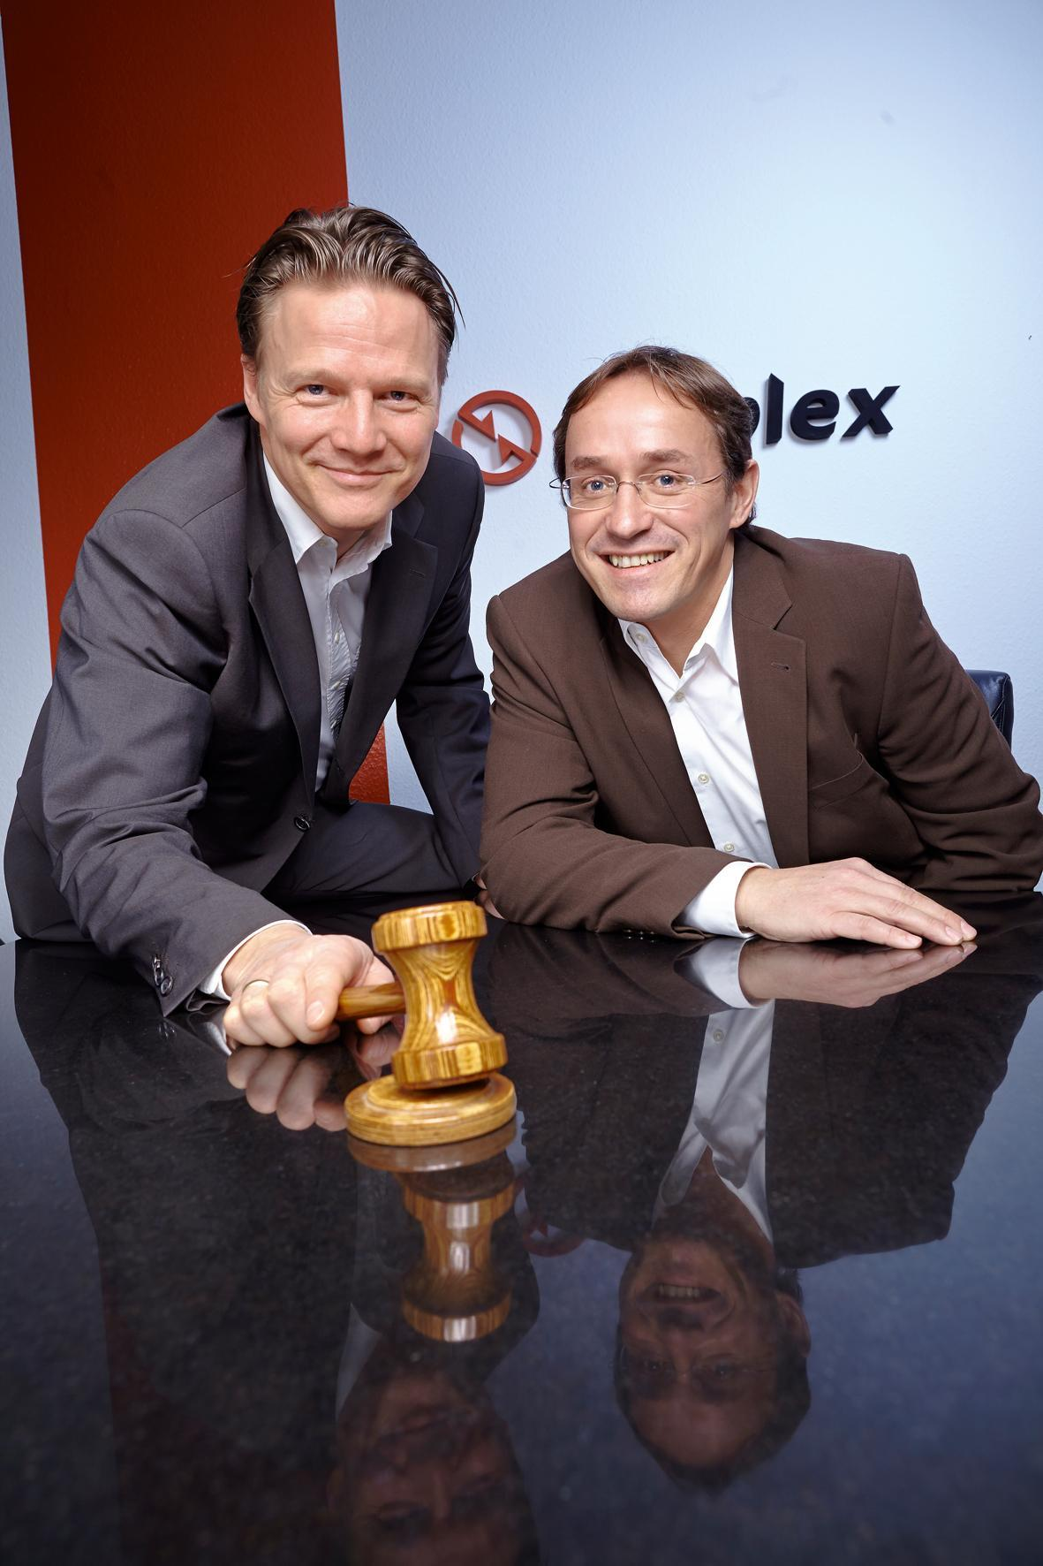
2019: MDs Michael Werker & Uli Stalter

